
MGH JFL Board of Trustees
Meeting Agenda – Sunday, October 17, 2025 @ 7:00pm
Location: Blue Margaritas
105 Elizabeth Pointe Dr., Germantown Hills, IL 61548
Call to Order
Charlie made a motion to call the meeting to order @ 7:05 pm. Motion was 2nd by Pete. Motion passed unanimously.
Attendance
2024-2025 MGH JFL Board of Trustees Members
Position | Name | Attendance
President | Brad Grebner | X
Vice President/Fundraising | Tim Woelfel
Finance Director | Jarrad Koon | X
Secretary / Assistant Cheer Director | Amy Duffield | X
JFL OCI Director | Brad Grebner | X
Coaches Director | Chris Smith | X
Cheerleading Director | Jessica Kelly
Site Manager | Charlie Jackson | X

Assistant Equipment | Kyle Durst
Equipment | Dave Thompson | X
Assistant Equipment | Dakota Dealey | X
Concessions | Abbie Tabor | X
Assistant Concessions | Janel Davis
IT/Communications Director | Kyle Lavery | X
Flag Director | Pete Schultz | X
Member | Jeremy Whitman
Member | Jason Mulvaney | X

Guests: None
MGH JFL Board of Trustees Meeting
President & JFLOCI Report (Brad Grebner)
Motion to Approve August meeting minutes:
● Motioned: Pete
● Motioned 2nd: Chris
● Vote Results: Approved Unanimously
Game Cameras – Desire to order 5x xbox go camera kits (camera for use with cellphone, case, 13’ tripod, etc) @ ~$500.00 each – Total ~$2,500 - wasn’t discussed further due to current lack of volunteers for the program. People aren’t signing up to stream the games. The goal was to stream all home games. This didn’t happen this year.
Building Cameras – Status of building cameras- this is still in process.

Storage Shed For Practice Equipment – The Metamora Park District was wanting more information regarding the buildings (location of where the building will be placed, ect) Brad continues to work and communicate with the Park District to facilitate this discussion. Building will not be purchased/placed until after the season.

Desire to order storage shed for the park to store practice equipment and pads out be practice fields. See complete list of designs in Appendix.
Option 1 – 12’x24’ Lofted Garage – Painted $9,920 – Metal $11,460
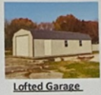
Option 2 – 12’x24’ Portable Garage – Painted $8,285 – Metal $9,615
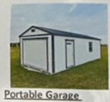
Option 3 – 12’x24’ Barn – Painted $6,700
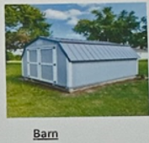
We need to talk to the park district to see if they have any restrictions on putting a shed at the park or restrictions on the type/design of the shed.
-Kyle made a motion to purchase a shed not to exceed $15,000. The motion was 2nd by Charlie.
-Motion was passed unanimously.
Volunteers Needed – Need board members, teams, and parents to step up more to help volunteer during game days! Volunteer numbers are down a lot this year! People are also signing up to help and then not always showing up to volunteer.
The board needs to come up with a better plan to get volunteers for the next season. What we have in place is no longer working. Other area sports require a higher volunteer fee, discussion was had about assigning teams to cover concessions when they are not playing.

Championship Weekend
-Need to form a committee- awaiting further communication from Brad after talking with OCI.
-Do we have guidelines and such from OCI?- Brad is going to get all information from OCI and communicate this to the board.

Finance (Jarrad Koon)
Checking Account Balance - $71,979.00
w/ $28,270 for raffle tickets & $19,935 for fall registration paid out
OCI Account - $xx,000
Tax Update:
● 2025 Annual Report Filed
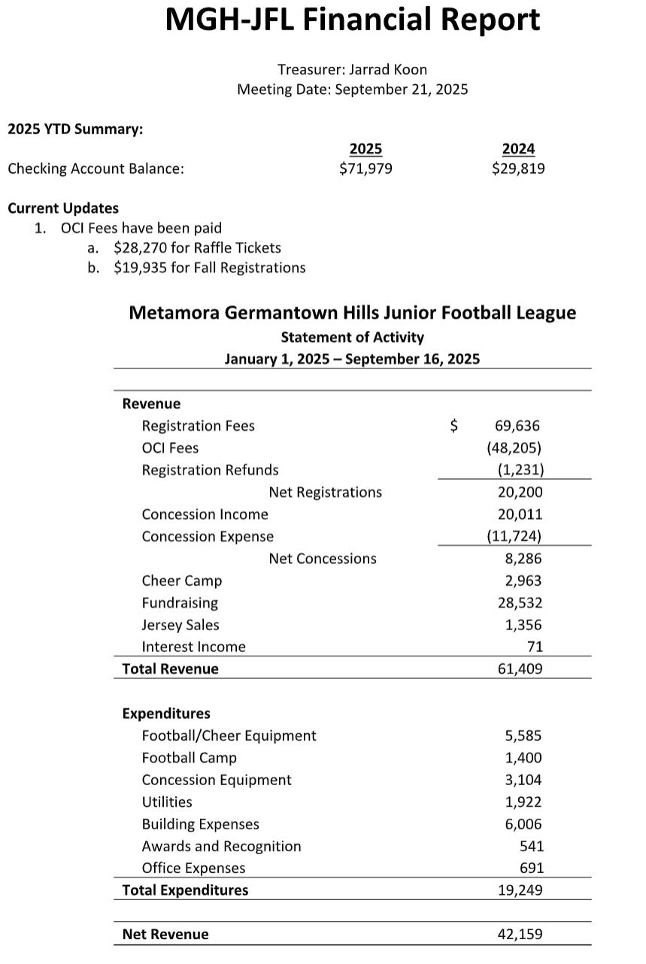

Coaches Director (Chris Smith)
Our area is doing very poorly in sportsmanship. As a group/area, Metamora is 15th out of 19 teams for sportsmanship. Coaches, players and fans all raise or lower our sportsmanship scores.

Fundraising/ Vice President (Tim Woelfel)
Board nominations & voting coming up
Tim to work w/ Kyle on secure online voting process

Discussed purchasing pink jerseys for all players/cheerleaders for the month of October. This purchase is being made per the request from a donation made to the program.
Chris made a motion to purchase enough jerseys for all kids in the program. Motion was 2nd by Pete
Motion passed unanimously.
- Jerseys were not going to be delivered until November, after season is over and therefore pink jerseys were not ordered this year. We will need to order these jerseys earlier in the year next year to ensure they are delivered prior to October games.
Site Manager (Charlie Jackson)
Bathroom Exhaust Fans – humidity is so high in the building causing mold. We need to do some pricing on this- bathroom fans are still in the works but have not yet been started.
- Could range between $500 to $2,000
Sofit to be finished
Field Maintenance – 3x irrigation valves to be fixed
Equipment (Dave)
Equipment turn in will begin once teams are finished with their season.
Cheer Director (Jessica Kelly)

Tim & Jess will develop charter for growth in 2026
Cheer Wants/needs:
Floor length mirror for cheer room
Hanging rods/hangers to hang uniforms/warmups
Totes to store cheer items
More red/black poms

Rubel wants to sponsor- purchase football to throw out, Jess to message Tim and Brandy

Jess has not been reimbursed for purchasing spirit items that were thrown out during games. The board had previously voted to provide $100 for spirit items. Jarred motioned for Amy to write Jessica a check for $100 to reimburse her for her purchases this season. Motion was 2nd by Dakota.

Jessica purchased warmup pants to ensure that all girls have the ability to wear the warmup pants this season. Jessica to turn in receipt for pants and will be reimbursed.

Jessica has been working with Pete on purchasing enough trophies for flag and cheer.
Concessions (Abbie Tabor)
Concessions
- Picnic Tables – Tim has emailed MTHS- the shop class is going to start designing the picnic tables and will give us a supply list of things that will need to be purchased. – On-going

Boys of Fall (Sept 27th) If people by tickets for Boys of Fall through the flyer we have, we will get $2 back. JFL will be cooking at the event again this year. Volunteers are still needed for this event.
Brad will get OCI tent and generator
Pete will bring a tent
Water will be donated
We have enough coolers but need to supply our own ice

We have done about $23,000 in sales thus far this year and had about $12,000 in profit.
We have had to hire 4 kids and spent $400 to pay their wages due to not having enough volunteers in the concession stand.
Flag Director- (Pete)
Pete has been working with Jessica to purchase flag trophies. There is going to be a flag graduation on Sept. 28th where the players who will be playing tackle next year will be recognized.
IT/Communications- (Kyle)
Updates needed – Important Dates Updated
Add Dumpster Dude to website for sponsor
-Need board member online voting form/tool
New Business Discussion

Adjournment
● Pete made a motion to adjourn the meeting at 8:07pm. Motion 2nd by Chris. Motion passed unanimously.
Next Meeting
Sunday, October 19th @ TBD
Action Items
Action Items: | Owner(s): | Deadline :

Concessions Director Report
Flag Director Report
JFL Storage Shed List
